Assiut University website: www.aun.edu.eg

SURGICAL USE OF FASCIA LATA GRAFTS AS BLADDER WALL SUBSTITUTES AFTER PARTIAL CYSTECTOMY IN DOGS

MANAR MOSTAFA MOHAMED ¹; MOHAMMED ADEL M. ALI ² AND MOHAMMED AHMED HAMDY ABDELHAKIEM ²
¹ Free Veterinarian, Post-Graduate Student at the Department of Veterinary Surgery, Anesthesiology, and Radiology, Fac. Vet. Medicine, Assiut University, Assiut; 71526, Egypt
² Department of Veterinary Surgery, Anesthesiology, and Radiology, Fac. Vet. Medicine, Assiut University, Assiut; 71526, Egypt

Received: 26 April 2024; Accepted: 5 August 2024

ABSTRACT

The current study aimed to evaluate the effectiveness of fascia lata for grafting of the urinary bladder. Clinical, ultrasonographic and radiographic evaluations were performed. The study was carried out on ten healthy mongrel dogs of both sexes. They were divided into two equal groups. The animals in the control group were subjected to cystectomies, followed by suturing of the remaining wall using an inverting suture technique. The dogs in the Fascia lata group were subjected to partial cystectomies followed by grafting using fascia lata which was harvested from the thigh region. The graft was sutured to the bladder using the inverting suture pattern. The results revealed that the animals in both groups were healthy throughout the experiment except two animals in the control group showed urinary incontinence at the early post-operative period. One animal in the fascia lata group showed incontinence and another one displayed arching of the back in the first three days post-operation. The ultrasonographic and radiographic evaluation revealed a well-contoured bladder without any leakage. The bladder volume was significantly decreased in the control group post-operatively compared to the pre-operative manual measurement. However, there was no significant variation in the bladder volume pre- and post-grafting in the fascia lata group when measured manually and radiographically. Ultrasound is considered an unreliable method for measuring bladder volume. The results showed that fascia lata is an easily harvested tissue used for grafting the urinary bladder. It causes no complications (leakage, stone formation), and it keeps bladder capacity within normal or close to normal.

Keywords: Dogs. fascia lata, autograft, urinary bladder, cystectomy

INTRODUCTION

The anatomy and physiology of the urinary bladder can be disrupted by many diseases, resulting in restricted urination (Walters and Weber, 2000). The diseases

Corresponding author: Abdelhakiem, M.A.H.
E-mail address: hamdysurgery@aun.edu.eg
Present address: Department of Veterinary Surgery, Anesthesiology, and Radiology, Fac. Vet. Medicine, Assiut University, Assiut; 71526, Egypt
that can reduce bladder capacity, include neurogenic, carcinogenic, rhabdomyo-sarcoma, and neurofibromatosis, multiple surgeries, patent urachus excision, devitalized tissue following bladder rupture, and inflammatory diseases like recurrent interstitial cystitis (Kispal et al., 2011; Valsangkar et al., 2016). Cystectomy is recommended for the majority of the above-mentioned affections (Granger et al., 2020; Ahmed et al., 2022).
Augmentation cystoplasty (AC) is a reconstructive surgery after partial cystectomies that aims to preserve the normal bladder capacity and prevent renal impairment in animals and humans through the decrease of intravesicular pressure (Salehipour et al., 2016). Different synthetic biomaterials, as well as autologous, homologous, and heterologous tissues have been used in AC (Breen et al., 2015).

Previous studies have established the use of various grafts for repairing and augmenting the urinary bladder, such as gastric and intestinal grafts, which are still the gold standard tissues for augmentation cystoplasty (Kispal et al., 2011; Abol-Enein et al., 2012; Gonçalves et al., 2021), but they were linked with considerable morbidity (Kropp et al., 1996; Pozzi et al., 2006; Sabetkish et al., 2014). In a previous study, two sources of tunica vaginalis grafts were used: one harvested from sheep and the other from dogs. The dog-derived tunica vaginalis graft produced effective, durable, and agreeable results, while the sheep-derived graft was ineffective in augmenting cystoplasty in dogs. The changes of results might be attributed to the species. The uses of tunica vaginalis as a graft may indicate that the graft must be harvested only from males to be used in both sex and this is considered a limitation of this type of graft (Ahmed et al., 2022). In previous studies, it has been demonstrated that biodegradable, collagen-based materials induce native bladder regeneration (Kambic et al., 1992; Elbahnasy et al., 1998). These materials can be quite expensive or require a considerable amount of preparation, such as porcine small intestine submucosa (SIS) (Kropp et al., 1996) and bladder acellular matrix grafts (BAMGs) (Probst et al., 2000).

There are two published papers about the use of fascia lata (FL) for augmentation cystoplasty in dogs and rabbits (Yonez et al., 2019; Ekder and Mahdi, 2021). In FL, collagen fibers are arranged in a three-dimensional network with a small amount of elastic fibers, which gives it sufficient strength and flexibility. Therefore, it is commonly utilized to reconstruct a variety of damaged tissues (Maksymowicz et al., 2012). Besides its easy harvest, it possesses other properties, such as low immunologic and inflammatory effects, non-toxic effects, low cost, and increased resistance to bacterial contaminations (Yonez et al., 2019). It has been used in the reconstruction of the abdominal wall in animals (Disa et al., 1996), as a substitute for repairing mucosal defects in the oral cavity of dogs (Ugurlu et al., 2004), as well as in the repair of canine perineum and diaphragmatic hernias (Suzuki et al., 2002; Bongartz et al., 2005; Guérios et al., 2017). Fascia lata can also be used successfully for reconstructing urethral defects and urethral fistulas in dogs (Atalan et al., 2005; Ayyildiz et al., 2006; LEE et al., 2019).

The current study aimed to investigate the effectiveness of using autologous fascia lata for augmentation cystoplasty in dogs. Special focus was given to clinical, ultrasonographic, and radiographic evaluation, as well as measurement of bladder volume or capacity.

MATERIALS AND METHODS

1. Study design
The study was conducted under the guidelines of the Faculty of Veterinary Medicine, Assuit University, Egypt, in accordance with the OIE guidelines for the use of animals in research under No. 06/2024/0181. Additionally, the Institutional Animal Care and Use Committee of Assuit University's Faculty of Veterinary Medicine approved the study.

Ten healthy mongrel dogs of both sexes weighing between 9 and 20 kg (mean 13.85 Kg) and aged between 1 and 3 years (mean 1.9 years) were subjected to the following experimental study. Standard dog food was provided to the dogs, and they had free access to water. Before the study, the dogs were housed at the Faculty of Veterinary Medicine, Assuit University, for two weeks for close observation and acclimatization. Clinical data collected during the acclimatization period indicated that the animals were healthy. The dogs were divided into two equal groups. The control (C) group underwent ventral partial cystectomies followed by suturing the remaining wall using a 4/0 braided lactometer* 9-1 (polysorb; Tyco Healthcare, USA) and a continuous inverting suture pattern. The dogs in the Fascia late (FL) group were subjected to partial cystectomies followed by the application of a fascia lata graft at the ventral bladder defect, which was then sutured to the wall using 4/0 polysorb and a continuous inverting suture pattern.

2. Animal preparation and anesthesia
All the dogs were closely monitored for two weeks before the study. They received a subcutaneous injection of Ivermectin at a dose of 0.2mg/kg, given twice at a 14-day interval. In addition, they were administered Cefotaxime antibiotic at a dose of 22mg/kg IM 24 hours before the surgery. The dogs underwent a 12-hour fasting period before the surgery and were pre-medicated with atropine sulfate at a dose rate of 0.03mg/kg IM. Following this, 2% Xylazine Hcl (Xyla-Ject 20 mg/mL; Adwia Co. S.A.E. 10th Ramadan City, Egypt) at a dose of 2 mg/kg IM was injected. Ketamine HCL 5% (Ketamax 50; Troikaa Pharmaceuticals Ltd. India) at a dose of 5 mg/kg was injected IM after 10 minutes of xylazine administration. Later, the dogs received a 2.5% solution of thiopental sodium (Upper Egypt Pharmaceuticals (UP Pharma) for EPECO; 10th of Ramadan City, Egypt) in a prepared dose of 20 mg/kg via an intravenous cannula (20 G cannula applied into the cephalic vein). The thiopental sodium was injected very slowly, until the loss of reflexes and apnea were noticed in the animals. If apnea lasted more than 20-30 seconds, the animals were subjected to cardio-respiratory resuscitation. The abdominal region and surface of the left thigh were prepared aseptically in a routine manner before the operation. The urinary bladder was emptied using an 8F Foley catheter, which was fixed in place.

3. Preparation of the dog’s FL graft
The FL graft was obtained and prepared according to Ekder and Mahdi (2021). The surgeon was positioned facing the lateral surface of the left thigh while the dogs were lying on their right sides. The lateral side of the leg was incised longitudinally, about 5 cm above the lateral tibial epicondyle, and connecting the lateral femoral greater trochanter. To avoid injuring the iliotibial tract, the dissection was carefully performed. A 3 x 4 cm patch of fascia lata was harvested and placed in sterile phosphate buffer saline. The fascial defect was left open, and the surgical wound was closed in two layers. Subcutaneous tissues were closed using 2–0 Polyglactin 910 (Vicryl, Ethicon, Inc., Somerville, New Jersey, USA) in a simple continuous pattern, and 0 polysorb was used in a simple interrupted pattern to close the skin.

4. The augmentation cystoplasty (AC) of dogs using FL autograft
A 7 cm mid-line incision was made post-umbilical and extended downward to access the urinary bladder. After the bladder was exposed and emptied, moist, sterile laparotomy towels were used to isolate it from the rest of the abdominal organs. To handle the bladder, a stay suture was placed at the apex. A small incision was made on the ventral surface of the bladder with a scalpel to remove a 2x3cm section of the bladder wall “partial cystectomy”. Then, the FL graft was sutured to the edge of the bladder wall with 4-0 absorbable polysorb in a water-tight continuous inverting suture pattern (Figure 1). The grafted bladder was filled with 60 mL of distilled water using a previously inserted polyethylene urinary catheter to check for any leakage. The bladder was covered by a layer of omentum. The latter was anchored to bladder by two stitches. The urinary bladder was reduced to its normal site. The abdominal wall was closed by a simple continuous suture pattern for the Linea Alba and subcutaneous tissue using 0 polysorb, and the skin was closed by a simple interrupted pattern using 0 polysorb.

The animals in the control group were subjected to the whole surgical procedure, as in the FL group, but the bladder was sutured and closed without using a graft by continuous inverting suture technique (Figure 2).

5. Postoperative management
The dogs received broad-spectrum antibiotics (Amoxycillin-clavulanic acid combination; Synlux RTU; Zoetis, 1ml/20 kg daily for 5 days IM), and Meloxicam (2% MOVAC Adwia Co. 10th of Ramadan City, Egypt) 0.5 mg/kg S/C every 48 hours (3 injections). The surgical site and stitches were checked daily for any complications until the skin sutures were removed 12 days postoperatively.
6. Postoperative evaluation
Dogs in the current study were observed till the third month postoperatively for general health status, food intake, urination behavior, and frequency, as well as abdominal distension. Ultrasonography was performed on the dogs in the 11th week following surgery, using a 5 MHz micro convex and/or 5:8 MHz linear ultrasound transducers (Edan DUS 60 Vet; China).

The retrograde negative, and positive cystogram techniques were performed 11 weeks postoperatively, as described by Marolf and Park (2013). Lateral and Ventrodorsal plain radiographs were obtained before the contrast study. For positive cystography, the bladder was emptied using a Foley catheter, which was applied in the urethra into the bladder. The urinary bladder was inflated slowly using diluted iodinated contrast media (100-150 mg I/ml; Urografin 76%, Bayer (Pty) Ltd, South Africa), until full capacity was reached, which was detected through digital manipulation of the bladder from outside, and presence of resistance during progressive injection. The mAs were increased by about 30% to avoid underexposure. Radiographic images of the abdominopelvic region were taken for each dog, including lateral and ventro-dorsal views. The pneumocytography was performed as positive cytography except the positive contrast media was replaced with room air.

7. Bladder capacity evaluation was performed using three different methods (manually, ultrasonographically, and radiographically). Manually, the dogs were placed in a supine position and given light anesthesia. The bladder capacity was assessed before the experiment (baseline) and 12 weeks later by measuring the amount (mL) of normal saline needed to fill the UB after emptying without resistance using an 8F Foley catheter (Atalan et al., 1998; Yonez et al., 2019).
The ultrasonographic and radiographic bladder volume measurements were calculated using the following equation: Bladder volume = length x width x height x 0.52 (Araklitis et al., 2019).

The minimum and maximum urinary bladder volume was measured according to previous studies. 3.5 ml/kg was the minimum, while 20 ml/kg was the maximum (Atalan et al., 1999; Hamaide et al., 2003; Hu et al., 2016). The results of bladder volume, that was measured manually, radiographically, and ultrasonographically for each animal, were compared with the minimum and maximum volume.

8. Statistical analysis
All quantitative data were expressed as the mean ± standard error (SE). SPSS software version 21 (IBM Corp., Armonk, NY, USA) was used for statistical analysis. First, Levene's Test of Equality of Error Variances was used. The result of this test is a significant Kruskal-Wallis nonparametric test instead of one-way ANOVA to compare the measured bladder volume using different ways within and between the control and FL groups. The P-value was considered significant when the P value was lower than 0.05. One-way ANOVA is used to detect the difference between each physical parameter (temperature, heart rate and respiratory rate) in the control and FL groups at different times.

RESULTS

1. Clinical findings
The postoperative clinical follow-up immediately after the operation until 3 months later revealed that all dogs included in the present study survived till the end of the study. The water intake started after the recovery of anesthesia. The feed intake was resumed normally about 24-36 hours post-operatively. The follow-up of urination was concerned in the first 5 days after the operation, with careful inspection and visualization of the contour of the abdomen. The animals in two groups voided urine smoothly and normally without any effort. The urine was physically normal, without any clear changes that may affect its normal color, such as blood or pus. All animals were in good general health conditions for 3 months post-operatively. The results revealed no significant changes in the physical parameters (temperature, heart rate, and respiratory rate) in all dogs between the pre- and postoperative periods (till the 8th week post-operation) in the control and FL groups (Table 1). The results revealed that the animals in both groups were healthy throughout the experiment, except two animals in the control group showed urinary incontinence at the early post-operative period (first three days). One animal in the fascia lata group showed incontinence and another one displayed arching of the back in the first three days post-operation.

The ultrasonographic findings were normal in all dogs in two groups. The urine appeared anechoic causing a distal acoustic enhancement. The pseudo-sludge was clear in some cases in two groups, which disappeared with agitation of the bladder and change of the orientation of the transducer. The bladder wall was intact, hypoechogenic, and well-demarcated from the anechoic bladder contents. The bladder wall thickness at the ventral aspect (seat of operation and its surroundings) was 1.1 mm and 1.7 mm in the control and FL groups respectively. The bladder wall was clearly distinguished into 3 layers ultrasonographically. Two echogenic layers sandwiched a hypoechoic layer (Figure 3). The thickness of the bladder wall was increased towards the seat of grafting in FL groups, but the control group showed a regular wall with an even thickness along the whole ventral aspect of the urinary bladder (Figure 3). The colon was located dorsally in the far field in three animals in both groups. It caused a mild indentation of the dorsal bladder wall (Figure 3).

The bladder size was variable according to its volume and whether the animal was recently voided or not. The bladder was at its normal position in the caudoventral aspect of the abdomen, without any displacement or deviation in all animals in the two groups. The bladder shape was variable in animals from ovoid, ellipsoid, or rounded. The bladder density on the radiograph was homogeneous and free from any filling defects in all animals in two groups, either on the pneumocystography or positive cystography. The contrast media is evenly distributed all over the bladder. The bladder wall was regular, smooth, and intact. It was free from any point of adhesion with surroundings (Figures 4&5). The ventral bladder wall was intact and devoid of any rent, abnormal thickness. There was no substantial difference in the bladder wall thickness, especially at the ventral aspect on the pneumocystogram in all animals in both groups. It ranged from 0.6 to 0.7 mm. However, there were some changes in the FL group, where the bladder wall appeared undulating or in waving form.

Generally, there was a significant difference in the bladder volume measured in different ways between the control and FL groups. The ultrasound-measured bladder volume was clearly lower than the manually measured before the operation, radiography and using the maximum bladder volume (20 ml/kg). The P values were 0.001, 0.041, and 0.00 respectively. Logically, there was a significant decrease in the value of measured bladder volume using minimum previous data of bladder volume (3.5 ml/kg) relative to the maximum bladder volume (20 ml/kg). P value was 0.00. Also, the minimum bladder volume (3.5 ml/kg) was substantially lower than the pre-operative bladder volume (P= 0.03). (Figures 6&7).

In the control group, there was a significant decrease in the measured bladder volume manually post-operatively relative to the pre-operative manual measured volume (P= 0.04). The statistical analysis showed a lack of significant change between the measured bladder volume in the fascia lata group between the pre- and post-operative manual measurement (P= 0.746). The difference between the measured bladder volume using different ways in the control and fascia lata groups was summarized in Table (2) and was clear in Figures (6&7).

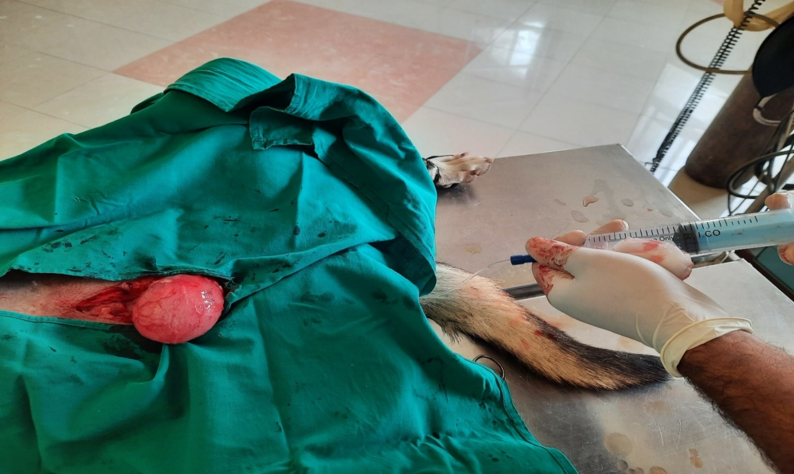  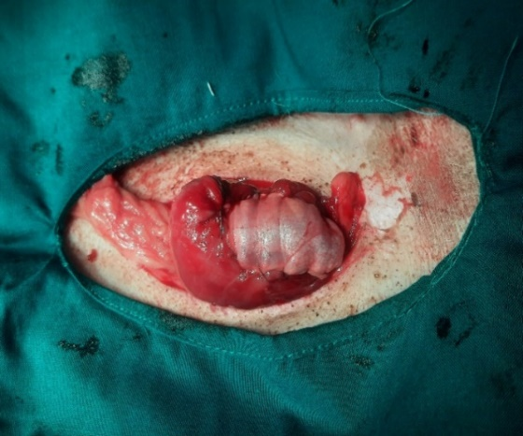  A |  | B
Figure (1). A. The urinary bladder before (A), and after grafting using fascia lata graft (B)
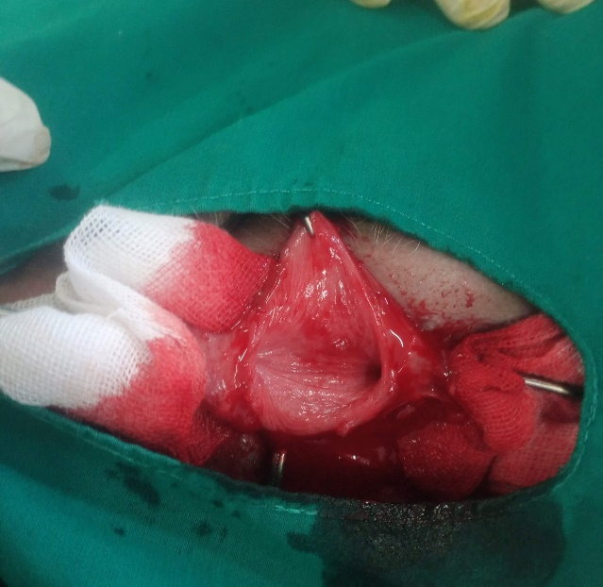  A | 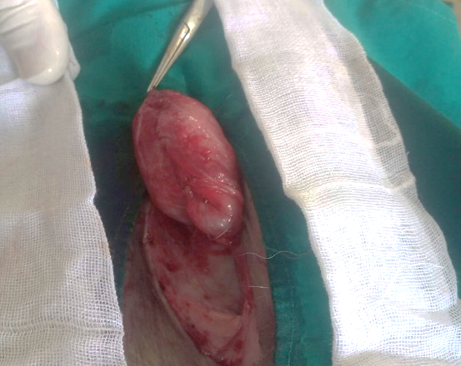  B
Figure (2): A. The urinary bladder after resection of a part of it in the control group, B. The suturing of UB after ventral wall resection using inverting technique without using of graft.

A  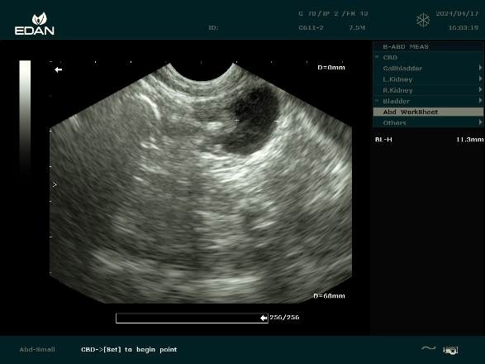 | 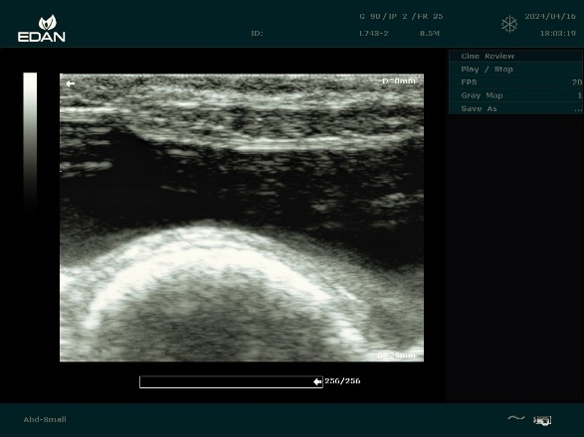  B
Figure (3): Ultrasonography of the UB in the control animals (A), and fascia lata group animals (B) at the 11th week post-operatively. There was a marked thickening of the ventral wall of the UB at the seat of grafting in the fascia lata group (orange arrows). Notice the indentation of the UB due to the colon (black arrow).

A  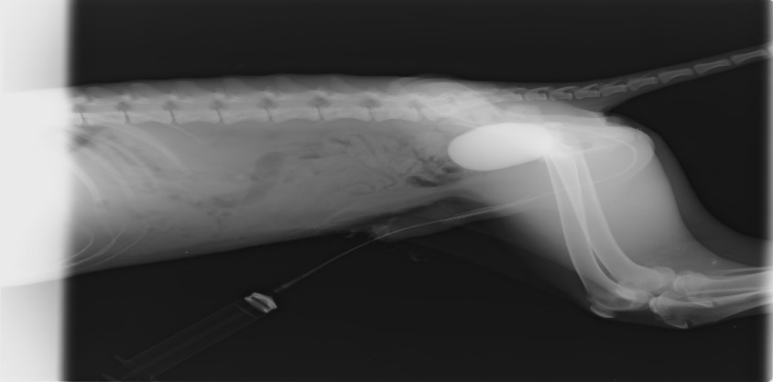  A | B  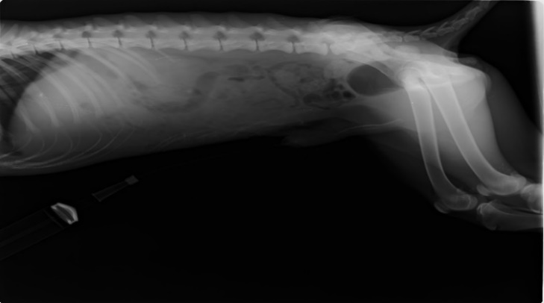
Figure (4): Radiographic evaluation of the urinary bladder using positive A, and negative B contrast media in the control group at the 11th week post-operation. The figures displayed the small-sized UB while keeping the smooth contour of the UB.
A B
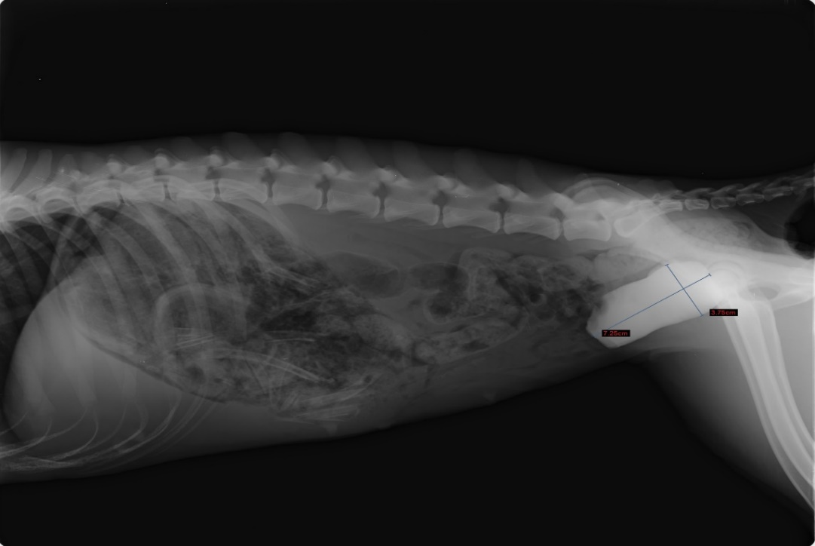  A | 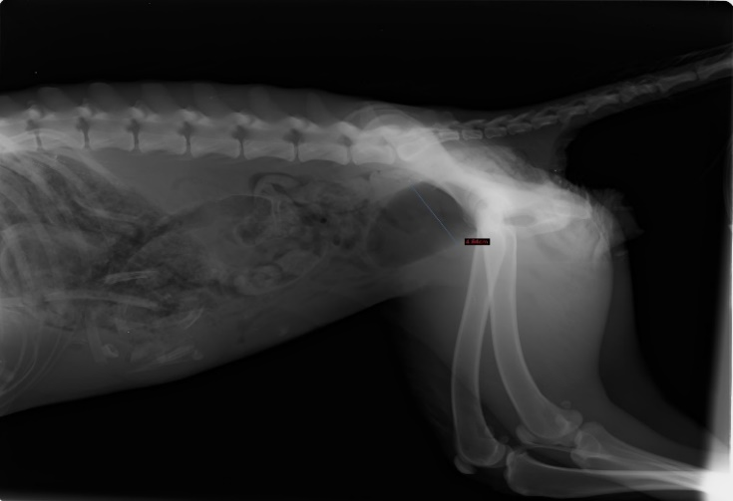  B
Figure (5): Radiographic evaluation of the urinary bladder using positive A, and negative B contrast media in the Fascia lata group at the 11th week post-operation. The figures displayed the normal size of the UB but with a slight change in the outer contour of the UB.

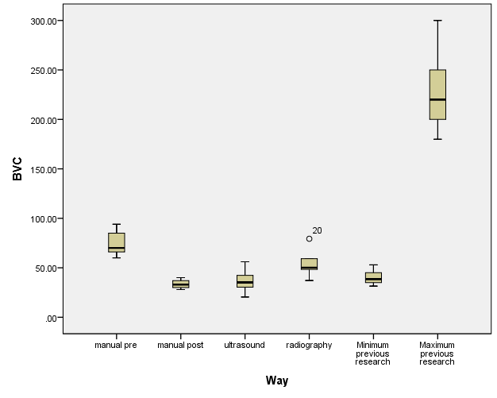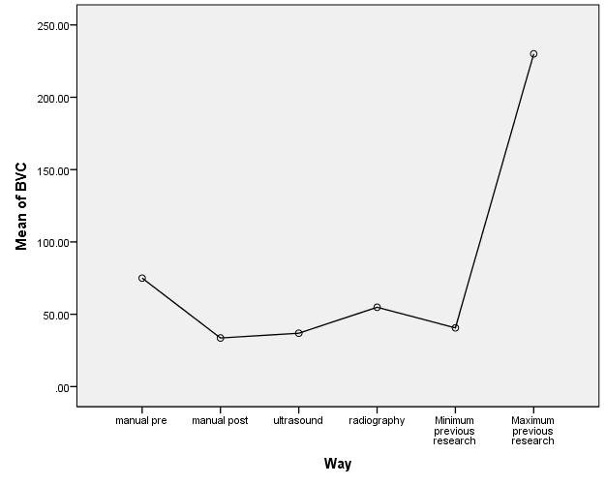

Figure (6): The measured bladder volume in the animals of the control group was calculated using different ways post-operatively and compared to the pre-operative manual measurement.
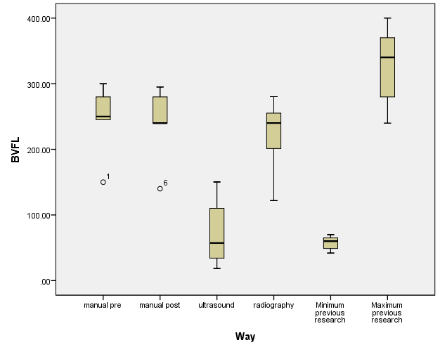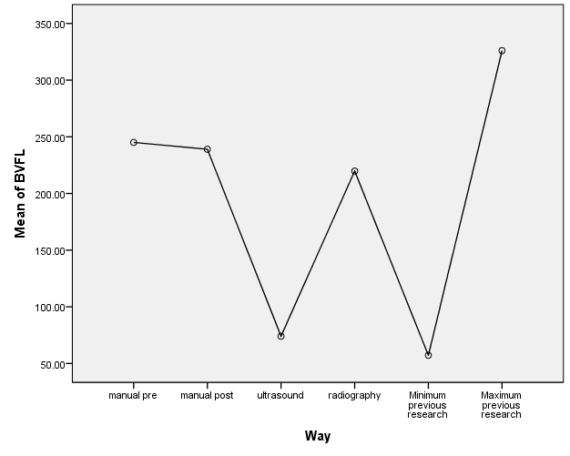
Figure (7): The measured bladder volume in the animals of fascia lata group was calculated utilizing different ways post-operatively and compared to the pre-operative manual measurement.

Table 1: The physical parameters (body temperature, heart rate, and respiratory rate) in the control and fascia lata groups. The data were described in mean± SE.
Time | Control (mean± SE) |  |  | Fascia Lata group (mean± SE)
 | T (ºC) | HR (b/m) | RR (breath/m) | T (ºC) | HR (b/m) | RR  (breath/m)
Pre-operative | 38.3± 0.21 | 73.6± 2.7 | 17.8± 0.86 | 38.22± 0.1 | 78.2± 0.92 | 17.6± 0.98
48 hours post | 38.16± 0.09 | 73.4± 2.6 | 22.8± 0.86 | 38.14± 0.05 | 78± 0.84 | 20.4± 1.21
1-week post | 38.38± 0.14 | 75.6± 1.8 | 20.4± 0.51 | 38.18± 0.07 | 78.4± 0.51 | 18.6± 1.21
2 weeks post | 38.12± 0.16 | 73.8± 2.5 | 17.0± 0.71 | 38.02± 0.09 | 78± 0.32 | 18.6± 1.03
4 weeks post | 38.28± 0.08 | 74.4± 3.5 | 16.4± 0.75 | 38.02± 0.07 | 79.2± 0.97 | 19.2± 1.16
8 weeks post | 38.18± 0.07 | 75.4± 1.9 | 18.2± 0.58 | 38.2± 0.08 | 79± 0.77 | 19± 0.71

T: temperature, HR: heart rate, RR: respiratory rate
ºC: Celsius
b/m: beats per minute
breath/m: breath per minute

Table 2: The bladder volume in the control and fascia lata groups was measured utilizing different ways. The data are expressed in mean± standard error. The P value is considered significant when it was lower than 0.05. The data were compared within the same group (column). The control group was superscribed with Capital letters, while the fascia lata group was superscripted with small letters. There were significant differences (0.05 ˃ P) between values superscribed with the same letters.
Way of measurement of bladder volume | Control  Mean± SE | Fascia lata  Mean± SE
Manual pre-operative | 75± 6.3^{ACE} | 245± 25.79^{ag}
Manual post-operative | 33.6± 2.2^{AB} | 239± 27.04^{bh}
Ultrasound | 36.91± 5.98^{CD} | 74.05± 24.56^{abcd}
Radiography | 54.84± 7.1^{G} | 219.79± 27.6^{ce}
Minimum previous research (3.5 ml/kg) | 40.6± 3.82^{EF} | 57.2± 5.15^{efgh}
Maximum Previous research (20ml/kg) | 230± 20.98^{BDFG} | 326± 29.26^{df}

DISCUSSION

The current study was conducted to evaluate the effectiveness of the grafting of the urinary bladder using fascia lata in dogs. The study investigated whether the fascia lata could be used as a substitute after a bladder defect and keep the bladder capacity within normal or close to normal. The results of the present study declared the effectiveness of the fascia lata to regain the normal contour and capacity of the urinary bladder. This was obvious when the bladder volume was measured manually before and after grafting. There was no significant difference between the measured volume pre- and post-grafting. On the other hand, the measured bladder volume before and after the operation in the control group had decreased substantially. These results about the successful use of the fascia lata for augmentation cystoplasty were consistent with the outcomes of a previous study in rabbits (Yonez et al., 2019) and another in dogs (Ekder and Mahdi, 2021). However, the current study confirmed the maintenance of normal bladder capacity after using the fascia lata for grafting.

The present study revealed that the radiographic calculation of the bladder volume was reliable and was close to the manual way of bladder volume measurement. In the fascia lata group, there was no difference in the measured bladder volume between the radiography and both the pre-and post-grafting manual way of measuring. There was no significant change in the bladder volume between the radiographic method and both of the pre and post-operative manual methods for calculation of the bladder volume in the control group, but there was a substantial difference between the pre- and post-manual methods in the same group. Due to one view showing only two dimensions of the urinary bladder, two views at least are required for obtaining three dimensions for appropriate calculation of the bladder volume (Thrall, 2013).

Multiple studies have utilized ultrasound to measure bladder volume in both humans and animals (Dicuio et al., 2005; Ghani et al., 2008; Kendall et al., 2020). However, the use of ultrasound in our current study yielded unreliable results. We observed a significant decrease in the measured volume when ultrasound was employed, as compared to manual measurement, radiography, and maximum bladder volume (20ml/kg). This decrease was observed in both the fascia lata and control groups. The estimation of bladder volume not capacity was directly measured according to the equation of Araklitis et al. (2019). When measuring bladder volume, a volume of urine within the bladder was not considered. Sometimes the dogs' bladders were full, empty, or recently voided. Thus, the ultrasound in our study measured only the remaining bladder volume, while the manual and radiographic methods were preceded by bladder inflation. We consider it a limitation of the present study, and ultrasound measurement of bladder volume in dogs requires further investigation, and the bladder should be filled with distilled water or physiological saline before measurement.
The results of the current study showed that the dogs were in good overall health throughout the entire experiment, after the grafting of the urinary bladder (UB) using FL. However, two dogs exhibited signs of urine incontinence and arching of the back during urination in the first three days following the surgery. This may be attributed to pain that was elicited with laparotomy and cystoplasty. Also, the urination process needs an increase in the intra-abdominal pressure, obtained from the contraction of the abdominal muscles. In the control group, urinary incontinence may be ascribed to the decrease of bladder capacity and threshold relative to the production volume of urine by kidneys. Bladder tone often decreases during the first 10 days after cystoplasty. This is considered normal in the early postoperative period and may suggest satisfactory healing at the grafting site (Dewangan et al., 2013).

Urine leakage and stone formation were not observed in this study. It is postulated that the choice of the suture type and pattern, as well as the tissue of the FL, may play a role in preventing these complications.

Several studies (Abass et al., 2011; Al-Asadi and Khwaf, 2014; Xiao et al., 2017) recommended the use of a single-layer running technique in bladder augmentation and cystotomy procedures. According to this technique, sutures in the bladder tissue are less likely to leak, and the procedure is quicker and stronger. Polydixenon suture material was also found safe for use in cystotomy and cystoplasty procedures involving homologous FL graft (Kosan et al., 2008; Al-Asadi and Khwaf, 2014; Yonez et al., 2019). The use of FL graft for cystoplasty in rabbits did not result in stone formation. Furthermore, the FL tissue did not exhibit mucus secretion, which can lead to stone formation, as observed in the stomach or ileum.

CONCLUSIONS

Based on the clinical, ultrasonographic, and radiographic results, Fascia lata is an easily harvested tissue from animals to be used for grafting the urinary bladder after its cystectomy. It causes no complications (leakage, and stone formation), as well as it keeps the bladder capacity within normal or close to normal.

REFERENCES

Abass, B.T.; Muhammad Amin, D.M.T.; Hassan, A.H. )2011(: Cystotomy Closure Using a Single-Layer Simple Continuous Versus Continuous Cushing Suture Patterns in Dogs.
Abol-Enein, H.; Faruqui, N.; Barakat, N. and Shokeir, A.A. )2012(: Does the afferent tubular segment in an orthotopic bladder substitution compromise ureteric antireflux properties? An experimental study in dogs. Arab J. Urol. 10, 125–130. https://doi.org/ 10.1016/j.aju.2012.02.008
Ahmed, M.F.; Metwally, E.; Mahmoud, Y.K.; Abuzeid, S.M.; El-Daharawy, M.H. and Hashem, M.A. )2022): Augmentation cystoplasty in dogs: A comparative study of different tunica vaginalis grafts. Vet. Anim. Sci. 16, 100247. https://doi.org/10.1016/j.vas.2022.100247
Al-Asadi, R.N. and Khwaf, N.B. )2014): A Comparative Study between Inverting and Appositional Suture Patterns for Cystotomy Closure in Dog: Rahi N. Al-Asadi and Natheria B. Khwaf. Iraqi J. Vet. Med. 38, 40–47. https://doi.org/ 10.30539/iraqijvm.v38i1.254
Araklitis, G.; Paganotto, M.; Hunter, J., Thiagamoorthy, G.; Robinson, D. and Cardozo, L. (2019): Can we replace the catheter when evaluating urinary residuals? Neurourol. Urodyn. 38, 1100–1105. https://doi.org/10.1002/nau.23963
Atalan, G.; Barr, F.J. and Holt, P.E. (1998): Estimation of bladder volume using ultrasonographic determination of cross-sectional areas and linear measurements. Vet. Radiol. Ultrasound Off. J. Am. Coll. Vet. Radiol. Int. Vet. Radiol. Assoc. 39, 446–450. https:// doi.org/10.1111/j.1740-8261.1998.tb01633.x
Atalan, G.; Barr, F.J. and Holt, P.E. (1999): Frequency of urination and ultrasonographic estimation of residual urine in normal and dysuric dogs. Res. Vet. Sci. 67, 295–299. https://doi.org/ 10.1053/rvsc.1999.0336
Atalan, G.; Cihan, M.; Sozmen, M. and Ozaydin, I. (2005): Repair of urethral defects using fascia lata autografts in dogs. Vet. Surg. VS 34, 514–518. https://doi.org/10.1111/j.1532-950X.2005.00077.x
Ayyildiz, A.; Nuhoglu, B.; Huri, E.; Ozer, E.; Gurdal, M. and Germiyanoglu, C. (2006): Using porcine acellular collagen matrix (Pelvicol) in bladder augmentation: experimental study. Int. Braz J Urol Off. J. Braz. Soc. Urol. 32, 88–92; discussion 92-93. https:// doi.org/10.1590/s1677-55382006000100015
Bongartz, A.; Carofiglio, F.; Balligand, M.; Heimann, M. and Hamaide, A. (2005): Use of autogenous fascia lata graft for perineal herniorrhaphy in dogs. Vet. Surg. VS 34, 405–413.
https://doi.org/10.1111/j.1532-950X. 2005.00062.x
Breen, M.; Phelps, A.; Estrada, C. and Chow, J.S. (2015): The role of imaging in pediatric bladder augmentation. Pediatr. Radiol. 45, 1440–1447. https://doi.org/10.1007/s00247-015-3349-1
Dewangan, R.; Sharma, A.K.; Kumar, N.; Kumar, A.; Singh, H.; Kumar, V.; Maiti, S.; Shrivastava, S.; Saxena, S. and Singh, R. (2013): Efficacy of bladder acellular matrix graft with and without cell seeding for cystoplasty in rabbits. Trends Biomater. Artif. Organs 27, 47–57.
Dicuio, M.; Pomara, G.; Fabris, F.; Ales, V.; Dahlstrand, C. and Morelli, G. (2005): Measurements of urinary bladder volume: Comparison of five ultrasound calculation methods in volunteers. Arch. Ital. Urol. Androl. Organo Uff. Soc. Ital. Ecogr. Urol. E Nefrol. Assoc. Ric. Urol. 77, 60–2.
Disa, J.J.; Klein, M.H. and Goldberg, N.H. (1996): Advantages of Autologous Fascia versus Synthetic Patch Abdominal Reconstruction in Experimental Animal Defects. Plast. Reconstr. Surg. 97, 801.
Ekder, E.S. and Mahdi, A.K. (2021): Augmentation Cystoplasty Using Autograft of Thigh Fascia Lata: Experimental Study in Canine Model. Ann. Romanian Soc. Cell Biol. 3029–3039.
Elbahnasy, A.M.; Shalhav, A.; Hoenig, D.M.; Figenshau, R. and Clayman, R.V. (1998): Bladder wall substitution with synthetic and non-intestinal organic materials. J. Urol. 159, 628–637.
Ghani, K.R.; Pilcher, J.; Rowland, D.; Patel, U.; Nassiri, D. and Anson, K. (2008): Portable ultrasonography and bladder volume accuracy--a comparative study using three-dimensional ultrasonography. Urology 72, 24–28. https://doi.org/10.1016/j.urology.2008.02.033
Gonçalves, R.; Wade, J.; Fransson, B. and Ngwenyama, T. (2021): Augmentation enterocystoplasty in a polytrauma dog with extensive bladder necrosis. Vet. Rec. Case Rep. 9, e82. https://doi.org/ 10.1002/vrc2.82
Granger, N.; Olby, N.J. and Nout-Lomas, Y.S. (2020): Canine Spinal Cord Injury Consortium (CANSORT-SCI), Bladder and Bowel Management in Dogs With Spinal Cord Injury. Front. Vet. Sci. 7, 583342. https://doi.org/10.3389/fvets. 2020.583342
Guérios, S.D.; Monteiro, J.F. and Da Silva, D.M. (2017): Fascia lata flap to repair perineal hernia in dogs: a preliminary study. Turk. J. Vet. Anim. Sci. 41, 686–691. https://doi.org/10.3906/vet-1703-32
Hamaide, A.J.; Verstegen, J.P.; Snaps, F.R.; Onclin, K. and Balligand, M.H. (2003): Validation and comparison of the use of diuresis cystometry and retrograde filling cystometry at various infusion rates in female Beagle dogs. Am. J. Vet. Res. 64, 574–579. https://doi.org/ 10.2460/ajvr.2003.64.574
Hu, H.Z.; Granger, N. and Jeffery, N.D. (2016): Pathophysiology, Clinical Importance, and Management of Neurogenic Lower Urinary Tract Dysfunction Caused by Suprasacral Spinal Cord Injury. J. Vet. Intern. Med. 30, 1575–1588. https://doi.org/10.1111 /jvim.14557
Kambic, H.; Kay, R.; Chen, J.F.; Matsushita, M.; Harasaki, H. and Zilber, S. (1992): Biodegradable pericardial implants for bladder augmentation: a 2.5-year study in dogs. J. Urol. 148, 539–543. https://doi.org/10.1016/s0022-5347 (17)36649-1
Kendall, A.; Keenihan, E.; Kern, Z.T.; Lindaberry, C.; Birkenheuer, A.; Moore, G.E. and Vaden, S.L. (2020): Three‐dimensional bladder ultrasound for estimation of urine volume in dogs compared with traditional 2‐dimensional ultrasound methods. J. Vet. Intern. Med. 34, 2460–2467. https://doi.org/10.1111/jvim.15959
Kispal, Z.; Balogh, D.; Erdei, O.; Kehl, D.; Juhasz, Z.; Vastyan, A.M.; Farkas, A.; Pinter, A.B. and Vajda, P. )2011): Complications after bladder augmentation or substitution in children: a prospective study of 86 patients. BJU Int. 108, 282–289. https://doi.org/10.1111/j.1464-410X.2010.09862.x
Kosan, M.; Gonulalan, U.; Ozturk, B.; Kulacoglu, S.; Ergüder, I., Akdemir, O. and Cetinkaya, M. (2008): Tissue reactions of suture materials (polyglactine 910, chromed catgut and polydioxanone) on rat bladder wall and their role in bladder stone formation. Urol. Res. 36, 43–9. https://doi.org/ 10.1007/s00240-007-0124-2
Kropp, B.P.; Rippy, M.K.; Badylak, S.F.; Adams, M.C.; Keating, M.A.; Rink, R.C. and Thor, K.B. (1996): Regenerative urinary bladder augmentation using small intestinal submucosa: urodynamic and histopathologic assessment in long-term canine bladder augmentations. J. Urol. 155, 2098–2104. https://doi.org/ 10.1016/s0022-5347(01)66117-2
Lee, D.-E.; Kim, K.-C.; Jeong, S.-W. and Yoon, H.-Y. (2019): Reconstruction of urethral defects using a fascia lata autograft in a dog. J. Vet. Med. Sci. 81, 237–240. https://doi.org/10.1292/ jvms.18-0190
Maksymowicz, K.; Marycz, K.; Szotek, S.; Kaliński, K.; Serwa, E.; Łukomski, R. and Czogała, J. (2012): Chemical composition of human and canine fascia lata. Acta Biochim. Pol. 59, 531–535.
Marolf, A.J. and Park, R.D. (2013): The urinary bladder, in Textbook of Veterinary Diagnostic Radiology. pp. 726–743.
Pozzi, A.; Smeak, D.D. and Aper, R. (2006): Colonic seromuscular augmentation cystoplasty following subtotal cystectomy for treatment of bladder necrosis caused by bladder torsion in a dog. J. Am. Vet. Med. Assoc. 229, 235–239. https://doi.org/10.2460/javma. 229.2.235
Probst, M.; Piechota, H.J.; Dahiya, R. and Tanagho, E.A. )2000(: Homologous bladder augmentation in dog with the bladder acellular matrix graft. BJU Int. 85, 362–371. https://doi.org/10.1046/j.1464-410x.2000.00442.x
Sabetkish, N.; Kajbafzadeh, A.-M.; Sabetkish, S. and Tavangar, S.M. )2014(: Augmentation cystoplasty using decellularized vermiform appendix in rabbit model. J. Pediatr. Surg. 49, 477–483. https://doi.org/10.1016/j.jpedsurg. 2013.07.016
Salehipour, M.; Mohammadian, R.; Malekahmadi, A.; Hosseinzadeh, M.; Yadollahi, M.; Natami, M. and Mohammadian, M. (2016): Renal capsule for augmentation cystoplasty in canine model: a favorable biomaterial? Int. Braz. J. Urol. Off. J. Braz. Soc. Urol. 42, 383–388. https://doi.org/ 10.1590/S1677-5538.IBJU.2014.0680
Suzuki, K.; Takahashi, T.; Itou, Y.; Asai, K.; Shimota, H. and Kazui, T. (2002): Reconstruction of diaphragm using autologous fascia lata: an experimental study in dogs. Ann. Thorac. Surg. 74, 209–212. https://doi.org/10.1016/ S0003-4975(02)03635-4
Thrall, D. (2013): introduction to radiographic interpretation, in: Textbook of Veterinary Diagnostic Radiology. Elsevier Saunders St. Louis, pp. 74–86.
Ugurlu, K.; Hüthüt, I.; Özçelik, D.; Özer, K.; Sakz, D.; Yldz, K. and Bas, L. (2004): Epithelialization Process of Free Fascial Flaps Used in Reconstruction of Oral Cavity Mucosa Defects in Dogs. Plast. Reconstr. Surg. 113, 915. https://doi.org/10.1097/01.PRS.0000105625.27802.64
Valsangkar, R.S.; Rizvi, S.J. and Goyal, N.K. (2016): Extended partial cystectomy with augmentation cystoplasty in urachal adenocarcinoma: An oncologically favorable but underutilized alternative to radical cystectomy. Urol. Ann. 8, 369. https://doi.org/10.4103/0974-7796.184894
Walters, M. and Weber, A. (2000): Anatomy of the lower urinary tract, rectum and pelvic floor. Urogynecology Pelvic Reconstr. SurgeryWalters MD Karram MM 2nd Mosby St Louis MO 3–13.
Xiao, D.; Wang, Q.; Yan, H.; Qin, A.; Lv, X.; Zhao, Y.; Zhang, M.; Zhou, Z.; Xu, J.; Hu, Q. and Lu, M. (2017): Comparison of morphological and functional restoration between asymmetric bilayer chitosan and bladder acellular matrix graft for bladder augmentation in a rat model. RSC Adv. 7, 42579–42589. https://doi.org/10.1039/C7RA07601K
Yonez, M.K.; Atalan, G.; Karayigit, M.O. and Alpman, U. (2019): Use of fascia lata autograft for repair of urinary bladder defect in rabbits. Acta Vet. Brno 88, 57–63. https://doi.org/10.2754/avb201988 010057

الاستخدام الجراحي لطعوم اللفافة العريضة كبدائل لجدار المثانة
بعد الاستئصال الجزئي للمثانة في الكلاب

منار مصطفى محمد ، محمد عادل محمد على ، محمد احمد حمدى عبد الحكيم

Email: hamdysurgery@aun.edu.eg Assiut University website: www.aun.edu.eg

تهدف الدراسة الحالية إلى تقييم مدى فعالية اللفافة العريضة لتطعيم المثانة البولية. تم إجراء التقييمات السريرية والموجات فوق الصوتية والشعاعية. أجريت الدراسة على عشرة كلاب هجينة سليمة من كلا الجنسين. وتم تقسيمهم إلى مجموعتين متساويتين. خضعت المجموعة الضابطة لعملية فتح البطن واستئصال جزء من جدار المثانة (معظم الجدار البطنى للمثانة) متبوعة بخياطة الجدار المتبقي باستخدام تقنية الخياطة المقلوبة. خضعت مجموعة اللفافة العريضة لعملية فتح البطن واستئصال جزء من جدار المثانة (معظم الجدار البطنى للمثانة) متبوعة بالتطعيم باستخدام اللفافة العريضة التي تم حصادها من منطقة الفخذ. تمت خياطة رقعة اللفافة العريضة في المثانة باستخدام نمط الخياطة المقلوبة. أظهرت النتائج أن الحيوانات في كلا المجموعتين كانت صحية طوال مدة التجربة باستثناء حيوانين في المجموعة الضابطة أظهرا سلس البول في الفترة المبكرة بعد العملية الجراحية. أظهر أحد الحيوانات في مجموعة اللفافة العريضة سلس البول بينما أظهر حيوان آخر تقوس الظهر في الأيام القليلة الأولى. أظهر التقييم بالموجات فوق الصوتية والتصوير الشعاعي أن المثانة ذات محيط جيد. وانخفض حجم المثانة بشكل ملحوظ في المجموعة الضابطة بعد العملية الجراحية مقارنة بالقياس اليدوي قبل العملية. ومع ذلك، لم يكن هناك اختلاف كبير في حجم المثانة قبل وبعد التطعيم في مجموعة اللفافة العريضة عندما تم قياسها يدويًا وشعاعيًا. تعتبر الموجات فوق الصوتية طريقة غير موثوقة لقياس حجم المثانة. وأخيرًا، تعتبر اللفافة العريضة نسيجًا جيدًا يمكن الحصول عليه بسهولة من الحيوان ذاته واستخدامه لتطعيم المثانة البولية. كما ان اللفافة العريضة لا تسبب أي مضاعفات (تسرب، تكوين حصوات). كما أنها تحافظ على سعة المثانة ضمن المعدل الطبيعي أو بالقرب من المعدل الطبيعي.

