Assiut University web-site: www.aun.edu.eg

ACRYLONITRILE-INDUCED TOXOPATHOLOGICAL AND BIOCHEMICAL ALTERATIONS IN FEMALE ALBINO MICE

FATIMA JALIL ABD ALSAADA AND BUSHRA AL-KAISEI
Department of Pathology and Poultry Diseases, College of Veterinary Medicine,
University of Baghdad

Received: 22 July 2024; Accepted: 25 August 2024

ABSTRACT

Acrylonitrile (ACN) is an organic synthetic monomer that is widely used in food packaging and manufacturing. Our current study aimed to investigate toxic pathological effects and biochemical alterations in ACN-treated female mice. Seventy female mice were assigned into 3 groups and received oral distilled water, ACN (10.17 mg/kg b.w, 1/10 of LD50) twice a week and ACN (10.17 mg/kg b.w) three times a week, respectively. After 45, 90 and 120 days of treatment, blood samples and tissue specimens from the uteri were obtained for measurement of catalase (CAT) and malondialdehyde (MDA), and histopathological examination, respectively. It was found that ACN significantly reduced CAT levels in group 2 and 3 after 120 days of treatment compared to group 1. Moreover, CAT levels in group 3 were significantly decreased compared to that in group 2 after both times intervals, 45 and 90 days. ACN raised MDA concentration in group 3 after 120 days of treatment compared to groups 1 and 2. Histopathologically, ACN was seen to damage the uterus as it markedly caused congestion, hemorrhages, thrombosis, severe necrosis, and local and diffuse granulomatous inflammation. In conclusion, exposure of female mice to ACN induces pronounced hazardous toxic and pathological effects in the form of imbalance in the oxidant-antioxidant harmony and marked histopathological changes. The study recommends avoiding overeating products containing ACN to keep proper health of the female genital system.

Keywords: acrylonitrile, uterus, MDA, catalase, mice.

INTRODUCTION

Pollution with hazardous chemicals such as acrylonitrile (ACN), dioxins, and radioactive pollutants is a global problem with several harmful impacts on the environment and human health (AL-Okaily, 2015; Sultan and Al-Kaisi, 2024). The production of hazardous materials often results in the release of additional hazardous substances during the manufacturing process (Sultan et al., 2023; Alshumary et al., 2024).

Corresponding author: Fatima Jalil Abd Alsaada
E-mail: fatima.abd2207m@covm.uobaghdad.edu.iq
Present address: Department of Pathology and Poultry Diseases, College of Veterinary Medicine,
University of Baghdad
ACN is a very toxic compound with the formula C₃H₃N. It is widely employed in the production of acrylic fibers, resins, and plastics. It may also be found in food items, air pollution, cigarette smoke, and drinking water (Ali et al., 2019; Abd and Ibrahim, 2023; Sabeeh and Al-Awadi, 2024). The physical characteristics of acrylonitrile homopolymer include an opaque white or yellow substance with strength, general insolubility, and high softening temperatures (Gu et al., 2004; Humadi et al., 2020). Acrylonitrile units contain polar cyano groups (–CN), which enhance intermolecular forces and raise the softening points (Al-Azzawi et al., 2008; Mahalakshmi, 2003).
Human exposure to ACN can occur during production, transportation, and use (Small, 2000; Al-Sabaawy and Al-Kaisie, 2021). The two most probable exposure routes are inhalation of acrylonitrile that has evaporated into the air or consumption of polluted drinking water. Since ACN is highly soluble and stable in water, it is often found near chemical waste sites where it has been improperly handled or disposed of (Simons et al., 2016; Kobets et al., 2022). Additionally, cigarette smoke may potentially expose the public to acrylonitrile (Azeez, 2021).

ACN is metabolized primarily in two ways: directly via conjugation with glutathione (GSH) and through epoxidation to cyanoethylene oxide (CEO), mediated by cytochrome P-450 (CYP-450) (Al-Okaily and Ali, 2019). When GSH is consumed, cyanide (CN⁻) is released. This leads to the production of reactive oxygen species and initiates a chain reaction of free radical formation, resulting in lipid peroxidation (Zaher et al., 2021). Oxidative damage is caused by the depletion of GSH and the free radicals produced during ACN metabolism (Amin, 2018). Trans-3,5,4ʹ-trihydroxystilbene, commonly known as resveratrol (RES), is a polyphenolic phytoalexin primarily found in grapes. Red wine made from grapes also contains significant quantities of resveratrol (AL-Okaily, 2015; Al-Sabaawy and Al-Kaisie, 2021).

ACN has harmful effects on the ovaries and may negatively impact folliculo-genesis in rats and mice, as well as disrupt hormone levels in the pituitary-gonadal axis (Jiang, 1998; Jumma, 2024; Ibrahim et al., 2023). Studies have demonstrated that AN can mediate DNA damage (Mahmod et al., 2022). Furthermore, its metabolites, cyanide and 2-cyanoethylene oxide, have the potential to cause sustained tissue and cell damage, trigger pro-inflammatory signaling, lead to compensatory cell proliferation, and contribute to the emergence of cancer (Hogy, 1986; Naimi et al., 2019).
Accordingly, our current study aimed to investigate the toxic and pathological effects of ACN on the female reproductive system of mice.

MATERIALS AND METHODS

Materials
All procedures in the study were conducted in accordance with the guidelines of the European Union Council (86/609/EU) and were approved by the ethical committee for the use and care of animals (No. 746/2.4.2024, College of Veterinary Medicine, Baghdad University, Baghdad, Iraq). Seventy female albino mice (25–30 g, 9–10 weeks old) were obtained from the Cancer and Research Centre, Baghdad, Iraq. The animals were maintained under standard conditions with 12-hour light/dark cycles, a temperature of 20–22°C, and 54–60% humidity. They had ad libitum access to a basal diet and water. ACN (≥99%, Lot#BCBX3607) was purchased from Sigma Aldrich, Netherlands.

Methods
Treatment protocol
After 1 week of acclimatization, the mice were assigned to three groups:
Group 1: Twenty mice received normal saline (0.1 ml/100 g body weight) twice a week for 120 days and served as the control group.

Group 2: Twenty mice received 1/10 of the LD50 of ACN (10.17 mg/kg body weight). ACN was dissolved in distilled water and administered twice a week by gastric gavage, with the dose given in a volume of 0.1 ml/100 g body weight.

Group 3: Thirty mice received 1/10 of the LD50 of ACN (10.17 mg/kg body weight). ACN was dissolved in distilled water and administered three times a week by gastric gavage, with the dose given in a volume of 0.1 ml/100 g body weight.

The LD50 of ACN was determined using the Up-and-Down Dixon method (Kobets et al., 2022), and the calculated LD50 was found to be 101.68 mg/kg body weight.

Blood samples
Blood samples (1 ml per animal) were obtained from 8 animals per group at 45, 90, and 120 days. Blood was collected in gel tubes by heart puncture after anesthetizing the animals with diethyl ether (C₄H₁₀O, India). The blood samples were allowed to clot, and serum was then separated for the measurement of CAT and MDA levels. Serum samples were stored at -80°C until further use.

Biochemical measurement
The concentrations of CAT and MDA in serum were measured using the enzyme-linked immunosorbent assay (ELISA) method. Standard ELISA kits (Cloud-Clone Corp, USA) were used according to the manufacturer’s instructions.

Histopathological examination
At the three-time intervals (45, 90, and 120 days), mice were first anesthetized with diethyl ether and then sacrificed by cervical dislocation. The uteri were then obtained and fixed in 10% neutral buffered formalin for 24-48 hours. Specimens from the uterine wall were taken, dehydrated through a graded series of ethyl alcohol, cleared with xylene, and embedded in paraffin wax. Tissue sections of 4 μm thickness were cut and stained with hematoxylin and eosin (H&E) (Bancroft and Stevens, 1990). The stained sections were examined under a light microscope (CX31, Olympus, Tokyo, Japan) and photographed using a digital camera (Camedia C-5060, Olympus).

RESULTS

Biochemical assays
Effect of AN treatment on CAT
Treatment of mice with ACN significantly reduced CAT levels in Groups 2 and 3 after 120 days, compared to the control (Table 1). Additionally, CAT levels in Group 3 were significantly lower than those in Group 2 at both time points, 45 and 90 days (Table 1).

Table 1: Effect of Acrylonitrile treatment on catalase.
Groups | Mean ±SEM of catalase (nmol/ml)
 | 45 days | 90 days | 120 days
Group 1 | 8.08±0.12 ^{A,b} | 8.78±0.17 ^{A,a} | 9.03±0.04 ^{A,a}
Group 2 | 8.11±0.10 ^{A,a} | 8.31±0.16 ^{A,a} | 3.18±0.09 ^{B,b}
Group 3 | 4.13±0.09 ^{B,a} | 3.76±0.09 ^{B,a} | 3.25±0.09 ^{B,b}
LSD = 0.488* . Means with different capital letters in the same columns and different lowercase letters in the same rows are significantly different (P ≤ 0.05).

Effects of Acrylonitrile treatment on MDA
Treatment of mice with ACN significantly raised MDA levels in Group 3 after 120 days compared to Groups 1 and 2 (Table 1). Additionally, MDA levels in Group 3 were increased with the duration of treatment (Table 2).

Table 2: Effects of Acrylonitrile treatment on malondialdehyde .
Groups | Mean±SEM of MDA (nmol/ml)
 | 45 days | 90 days | 120 days
Group 1 | 5.15 ±0.07 ^{B,a} | 5.33 ±0.12 ^{B,a} | 5.18 ±0.09 ^{C,a}
Group 2 | 5.21 ±0.11 ^{B,a} | 5.23 ±0.07 ^{B,a} | 5.33 ±0.09 ^{C,a}
Group 3 | 8.13 ±0.08 ^{A,c} | 9.03 ±0.09 ^{A,b} | 10.91 ±0.14 ^{A,a}
LSD = 0.469 * . Means with different capital letters in the same columns and different lowercase letters in the same rows are significantly different (P ≤ 0.05).

Histopathological findings
Treatment of female mice with AN caused damage to the uteri at all three time points in both Groups 2 and 3. In Group 2, ACN induced congestion of blood vessels, intense mononuclear cellular infiltration, and severe necrosis after 45 days of treatment (Fig. 1A, B). After 90 days, it caused congestion of blood vessels and severe hemorrhages (Fig. 1C), and after 120 days, granulomatous inflammation was observed (Fig. 1D).

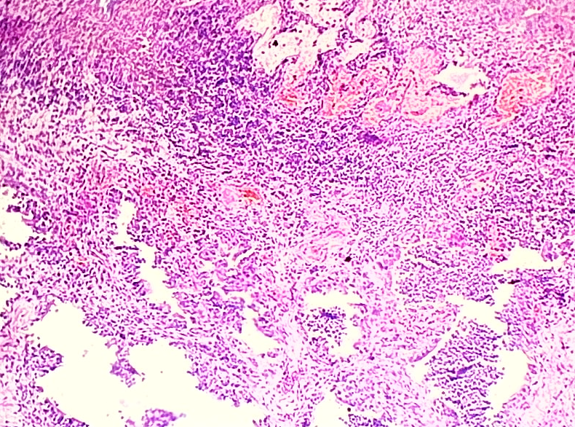
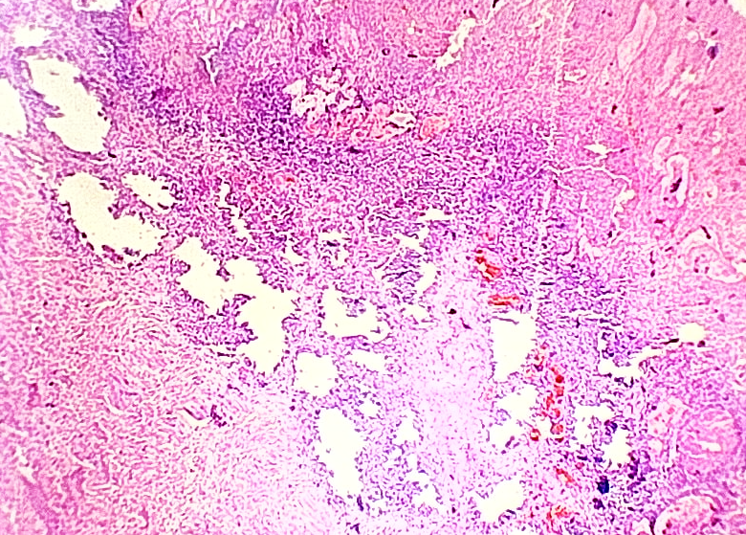
∗
∗
∗

∗

B
A

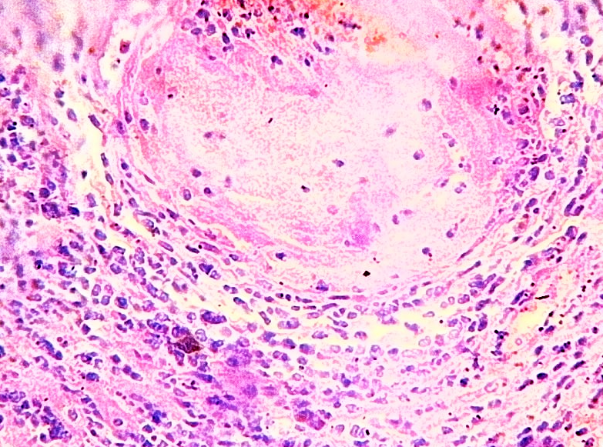
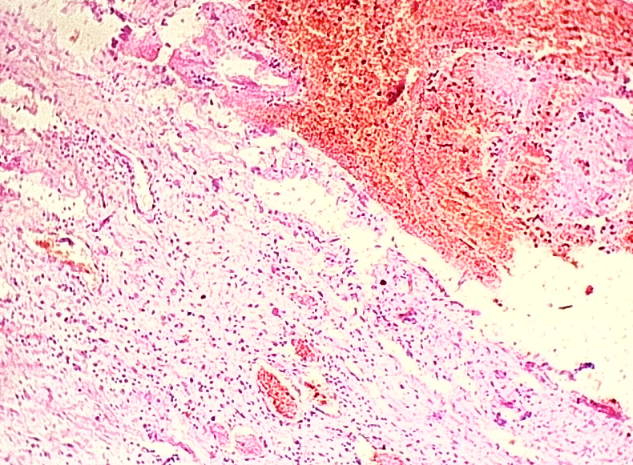

∗
∗

D
C

Fig. 1: Effects of ACN treatment on the uterus of mice in Group 2. A and B: Congestion of blood vessels (thin arrows), intense mononuclear cellular infiltration (asterisks), and necrotic areas (thick arrows) after 45 days of treatment. C: Congestion of blood vessels (arrow) and severe hemorrhages (asterisk) after 90 days of treatment. D: Granulomatous inflammation (asterisk) after 120 days of treatment. H&E, 200x magnification.

In Group 3, ACN induced congestion and thrombosis of blood vessels, as well as the formation of granulomatous tissue after 45 days of treatment (Fig. 2A). Endometrial thickening with mononuclear infiltration was also observed (Fig. 2B). After 90 days of treatment, the uteri exhibited extensive hemorrhages (Fig. 2C). After 120 days, ACN caused severe necrosis accompanied by hemorrhages and mononuclear cellular infiltration (Fig. 2D).
DISCUSSION

ACN has been shown to significantly decrease CAT levels and increase MDA concentrations compared to untreated controls. This effect is attributed to AN’s ability to induce lipid peroxidation (Al-Sabaawy and Al-Kaisie, 2021). During its metabolism, ACN liberates cyanide, a potent generator of reactive oxygen species (ROS), through inhibition of the mitochondrial respiratory chain and several antioxidant enzymes. Additionally, ROS can be produced through the cytochrome P450 oxidation of ACN products, such as acrylonitrile, dibromoacetonitrile, and chloracetone nitrile (Dixon, 1980). These ROS subsequently decrease CAT levels and increase MDA concentrations. ACN is much less reactive compared to its major metabolite, 2-cyanoethylene oxide (CEO), which is produced either by the conjugation of ACN with glutathione or by the epoxidation of ACN by microsomal cytochrome P450 (El-Sayed et al., 2003; Ota et al., 1998).

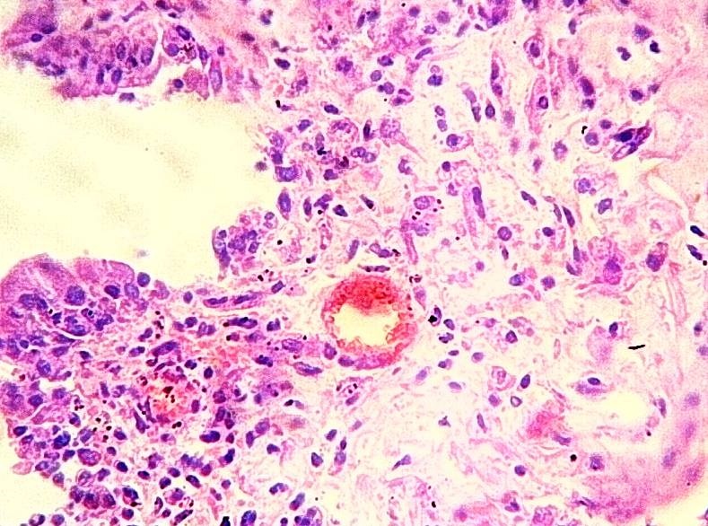
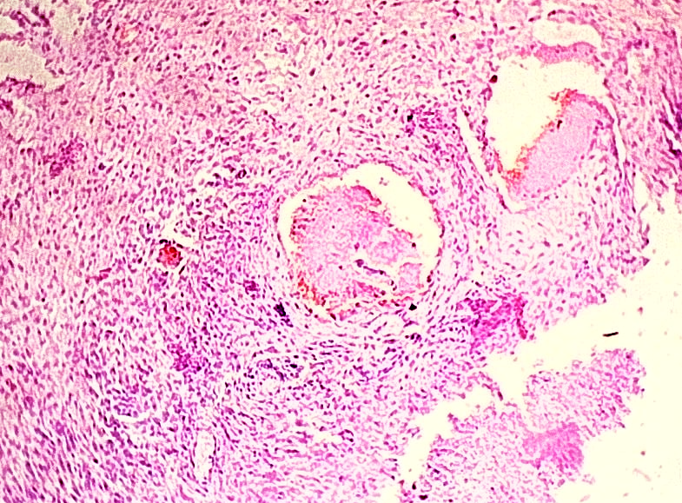

∗
∗

A
B

∗
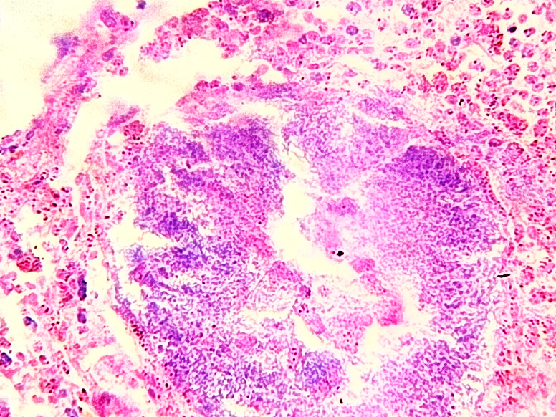
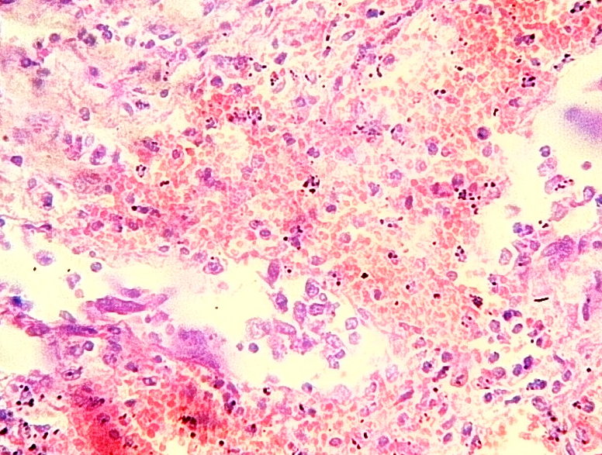
∗
∗

∗
∗

D
C

Fig. 2: Effects of AN treatment on the uterus of mice in Group 3. A: Thrombosis of blood vessels (arrows) and granulomatous tissue formation (asterisk) after 45 days of treatment. B: Congestion of blood vessels (arrow) and endometrial thickening (asterisk) after 45 days of treatment. C: Intense hemorrhages (asterisks) after 90 days of treatment. D: Severe necrosis (asterisk) and intense hemorrhages (small asterisks) after 120 days of treatment. H&E, 200x.

The most pronounced pathological lesions induced by ACN in Groups 2 and 3 at all three time points were congestion of blood vessels, thrombosis, severe necrosis, and granulomatous inflammation associated with mononuclear cellular infiltration. Although there is limited data specifically on the pathological effects of ACN on the uterus of female mice, similar effects have been reported in other organs. For example, Szabo et al. (1980) found that ACN treatment in rats led to early damage of the vascular endothelium in the adrenal cortex of nearly all treated animals. The authors also observed platelet aggregation and fibrin precipitation at the site of vascular endothelial damage, accompanied by decreased circulating platelets and fibrinogen, as well as increased prothrombin, partial thromboplastin, and thrombin times (Szabo et al., 1980). This vascular endothelial damage and disruption of the hemostatic process might mediate the thrombosis and hemorrhages observed in our study. Necrotic changes and granulomatous tissue formation are likely consequences of this vascular damage. Similarly, Silver et al. (1982) reported that ACN administration in rats caused focal superficial necrosis in the liver, along with hemorrhagic gastritis in the distended fore stomach.

In conclusion, administering 1/10 of the LD50 of ACN to female mice adversely affects catalase activity and induces lipid peroxidation. The vascular changes caused by ACN may mediate additional pathological effects, including necrotic and granulomatous alterations.

REFERENCES

Abd, A.A. and Ibrahim, N.S. (2023): Induction of oestrus by Sulpiride and measurement of estrogen hormone in Iraqi Awassi Ewes during the out of breeding season. The Indian Veterinary Journal 100 (12): 15-18.‏
Al-Azzawi, A.M.; Al-Tamimi, E.O. and Ali, R.A. (2008): Synthesis and copolymerization of several Nsubstituted acrylamide. Um-Salama Science Journal 5(4): 619-26.
Ali, A.A.; Laith, S.Y. and Saad, T.R. (2019): Effect of polymorphism G(129)R in growth differentiation factor 9 gene (GDF9) on Awassi ewes that breed out of season. Biochemical and Cellular Archives 19(2): 4649-4653.
AL-Okaily, B.N. (2015): Role of alcoholic extract of Roket (Eruca sativa) leaves on male reproduction of experimentally induced-oxidative stressed rats: Baraa Najim AL-Okaily and Ahmed Jasim Nowfel. The Iraqi Journal of Veterinary Medicine 39(2): 47-54.
Al-Okaily, B.N. and Ali, E.H. (2019): Effect of pomegranate seed oil against hepatotoxicity-induced by sodium fluoride in adult female rats (part II). The Iraqi Journal of Veterinary Medicine. https://doi.org/10.30539/iraqijvm.v43i1.480 ‏
Al-Sabaawy, H.B. and Al-Kaisie, B.I. (2021): Histological effects of chronic sodium fluoride toxicity on some reproductive organs of male and female adult albino rats. Iraqi Journal of Veterinary Medicine 35(4): 705-711.‏
Alshumary, H.O.; Jumma, Q.S.; Khorsheed, H.H. and AlKaisi, B.I. (2024): Assessment of the toxic effect of environmental pollution by 2, 3, 7, 8-Tetrachlorodibenzo-p-dioxin (TCDD) on the female reproductive system by pathological and biochemical assay in Albino female rats. Egyptian Journal of Veterinary Sciences 55(5): 1409-1415.‏
Amin, F.A.M. (2018): Effects of Azorubine Food Additive on Female Reproductive Organs and Hormones in Sprague Dawley Rat. The Iraqi Journal of Veterinary Medicine 42(2): 67-72.‏
Azeez, O.H. (2021): Evaluation of some male and female rats' reproductive hormones following administration of aspartame with or without vitamin C or E.‏ The Iraqi Journal of Veterinary Medicine https://doi.org/ 10.30539/ijvm.v45i2.1256
Bancroft, J.D. and Stevens, A. (1990): Theory and Practice of Histological Technique. Churchill Livingstone, Edinburgh. 113–305.
El-Sayed, el S.M.; Abo-Salem, O.M.; Abd-Ellah, M.F. and Abd-Alla, G.M. (2008): Hesperidin, an antioxidant flavonoid, prevents acrylonitrile-induced oxidative stress in rat brain. J Biochem Mol Toxicol 22: 268–273.
Gu, Y.; Zeng, J.; An, J.; Dai, W. and Li, X. (2004): Hematoporphyrin monomethyl ether photodynamic damage on HeLa cells by means of reactive oxygen species production and cytosolic free calcium concentration elevation. Cancer letters 8 (1): 43-54.
Hogy, L.L. and Guengerich, F.P. (1986): In vivo interaction of acrylonitrile and 2- cyanoethylene oxide with DNA in rats. Cancer Res 46(8): 3932-3938.
Humadi, AA.; AL-Kaisei, BI. and Humadi, TJ. (2020): Acrylonitrile testicular seminoma in beagle male dogs (pathological and hormonal assay). Plant archives 1;20(1).
Ibrahim, A.E.S.; Abo El Wafa, S.M.; Khodeary, M.F.; Parmar, A. and Elnajjar, N.S. (2023): Comparative Antioxidant Effects Of N-Acetylcysteine and Curcumin On Titanium Dioxide Nanoparticles Induced Orchidotoxicity In Healthy Adult Albino Rats. The Egyptian Journal of Forensic Sciences and Applied Toxicology 22(4): 127-143.
Jiang, J.; Xu, Y. and Klaunig, J.E. (1998): Induction of oxidative stress in rat brain by acrylonitrile (ACN). Toxicological Sciences 46(2): 333-341.‏
Jumma, Q.S. (2024): Detection of ESBL E.coli That Carried STX1 and STX2 Form Common Carp (Cyprinus carpio) in Salhaldeen Province. Egyptian Journal of Veterinary Sciences 55(4): 1165-1170.
Kobets, T.; Latropoulos, M.J. and Williams, G.M. (2022): Acrylonitrile induction of rodent neoplasia: Potential mechanism of action and relevance to humans. Toxicology Research and Application 6: 1–33.
Mahalakshmi, K.; Pushpakiran, G. and Anuradha, C.V. (2003): Taurine prevents acrylonitrile-induced oxidative stress in rat brain. Polish journal of pharmacology 55(6): 1037-1044.‏
Mahmod, W.S.; Al-Jumaili, E.F. and Mohamad, N.B. (2022): Qualitative and Quantitative evaluation of the extracted flavonoids in Iraqi-Sumac (Rhus coriaria L.). Iraqi journal of biotechnology 21(1).
Naimi, M.; Shariati, M.; Naimi, S. and Edalatmanesh, M.A. (2019): N-Acetylcysteine improves acrylamide-induced changes in ovarian tissue and serum levels of pituitary-ovarian axis hormones in adult rats. European Journal of Biology 78(2): 75-81.
Ota, H.; Igarashi, S.; Hatazawa, J. and Tanaka, T. (1998): Endothelial nitric oxide synthase in the endometrium during the menstrual cycle in patients with endometriosis and adenomyosis. Fertil Steril 69: 303-308.
Sabeeh, S.I. and Al-Awadi, A.Q. (2024): Resveratrol Mitigates Acrylonitrile-induced Thyroid and Adrenal Toxicity in Rats.‏ Journal of Angiotherapy 8(4).
Silver, E.H.; McComb, D.J.; Kovacs, K. and Szabo, S. (1982): Limited hepatotoxic potential of acrylonitrile in rats. Toxicology and Applied Pharmacology 64: 131-139.
Simons, K.; De Smedt, T.; Stove, C.; De Paepe, P.; Bader, M.; Nemery, B. and Van Nieuwenhuyse, A. (2016): Short-term health effects in the general population following a major train accident with acrylonitrile in Belgium. Environmental research 148, 256-263.‏
Small, I.M. (2002): Solvent recovery handbook. CRC Press.‏
Sultan, A.A. and Al-Kaisi, B. (2025): Protection of Resveratrol Against Nephrotoxicity in Rats Produced by 2, 3, 7, 8-Tetrachlorodibenzo-p-dioxin. Egyptian Journal of Veterinary Sciences 56(3): 605-616.‏
Sultan, A.A.; Hameed, M.S.; Humadi, A.A.; Al-Kaisei, B.I. and AL-Ezzy, A.I.A. (2023): Protective role of chlorophyllin against thyroid adenoma induced by polychlorinated biphenyls: (pathological and hormonal assay). In AIP Conference Proceedings 2475(1). AIP Publishing.‏
Szabo, S.; Hüttner, I.; Kovacs, K.; Horvath, E.; Szabo, D. and Horner, H.C. (1980): Pathogenesis of experimental adrenal hemorrhagic necrosis ("apoplexy"): ultrastructural, biochemical, neuropharmacologic, and blood coagulation studies with acrylonitrile in the rat. Lab Invest 42: 533-46.
Zaher, A.R.; AL-Rekabi, F.M. and Hatif, S.A. (2021): Some teratogenic outcomes in rats exposed to zinc chloride pre and post pregnancy. The Iraqi Journal of Veterinary Medicine 45(2): 41-45.‏

التأثيرات السمية المرضية والكيميائية الحيوية لمادة الأكريلونيتريل على الجهاز التناسلي لأناث الفئران البيضاء

فاطمة جليل عبد السادة، بشرى ابراهيم القيسي
‏فرع الفسلجة والكيمياء الحياتية والأدوية، كلية الطب البيطري، جامعة بغداد، العراق

الملخص العربي:
الأكريلونيتريل (ACN) هو هو مركب كيميائي عضوي يستخدم على نطاق واسع في تغليف وتصنيع المواد الغذائية. الهدف من هذه الدراسة هو معرفة تأثير ACN على الرحم الأنثوي للفئران بيوكيميائيا ونسيحيا. تم إجراء الاختبارات البيوكيميائية لـلماونديالدهيد MDA و الكاتالاز CAT. أجريت التجربة الأولى لتقدير LD50 (السمية الحادة ACN) على 5 إناث فئران. تم تقسيم عدد 70 انثى من الفئران البيضاء للتجربة الثانية (السمية المزمنة). وتم تقسيمهم إلى ثلاث مجموعات. تتكون المجموعة الضابطة السلبية (G1) من 20 فأرة أنثى. لمدة 120 يومًا، تم إعطاء 1/10 (10.17) من الجرعة المميتة LD50 من ACN عن طريق التزقيم الفموي مرتين اسبوعيا إلى 25 أنثى فأر (G2). اما المجموعة الثالثة (G3) احتوت على 25 انثى التي تم فصلها خصيصًا لغرض إعطاء 1/10 (10.17) من LD50 من ACN عن طريق التزقيم الفموي 3 مرات اسبوعيا لمدة 120 يومًا. أظهرت النتائج الكيموحيوية انخفاضاً معنوياً P<0.05 في الكاتلاز في (G3) خاصة في اليوم 120 (3.25 ±0.09) بالمقارنة مع المجموعة الضابطة بينما أظهرت MDA زيادة معنوية في المجموعتان(G3,G4) ((9.5±0.15، 10.91 ±0.14) ) خاصة عند اليوم 120 مقارنة مع المجموعة الضابطة.
ظهرت تغيرات مرضية في الرحم في G3) و (G4 في اليوم 45 في جميع المناطق تمثلت في التهابات محدودة او منتشرة ، احتقان و تجلط في الأوعية الدموية ، نزيف بطانة الرحم، وارتشاح وحيدات النواة, ، زيادة سمك بطانة الرحم مع ارتشاح خلايا وحيدة النواة، موت الخلايا المبرمج, نخر بطانة الرحم، وجود بقايا نخرية في غدد بطانة الرحم وفي تجويف الرحم
وفي اليوم 90: نزيف واسع النطاق في كل طبقات الرحم ، واحتقان الأوعية الدموية، ونخر عضل الرحم مع ارتشاح الخلايا وحيدة النوى ومتعددة الأشكال في جميع طبقات الدم مع كريات الدم البيضاء في التجويف.
وظهر في اليوم 120 ورم حبيبي كبير، ونزيف، ونخر في خلايا بطانة الرحم: طبقة بطانة الرحم متقرحة مع منطقة نخر شديدة تخترقها خلايا أحادية ومتعددة الأشكال.
وتخلص هذه النتائج إلى أن الافراط في تناول المنتجات المحتوية على ACN يسبب تأثيرات خطيرة واضحة على الجهاز التناسلي الأنثوي (الرحم)، وانخفاض مستوى الكاتلاز وزيادة MDA ، كما تحدث تغيرات مرضية في الرحم.

الكلمة الرئيسية:، أكريلونيتريل، الرحم، MDA، الكاتلاز، السمية الحادة.

